


Database Management Lab Experiment (ENCS205)
Bachelor of Technology in
Computer Science and Engineering

Submitted by:

LUCKY KUMAR (240101001)
B. Tech CSE (Core) – 4th Semester Section: A

Submitted To:

MS. Mansi Kajal

School of Engineering & Technology
K. R. MANGALAM UNIVERSITY
Sohna, Haryana 122103, India feb-2026

EXPERIMENT: 9

Consider the following tables namely “DEPARTMENTS” and “EMPLOYEES” with their schemas are as follows:
Departments ( dept no , dept name , dept_location ); Employees ( emp_id , emp_name , emp_salary,dept_no);
- Develop a query to grant all privileges of employees table into departments table.
- Develop a query to grant some privileges of employees table into departments table.
- Develop a query to revoke all privileges of employees table from departments table.
- Develop a query to revoke some privileges of employees table from departments table.
- Write a query to implement the save point.

[QUERY]:

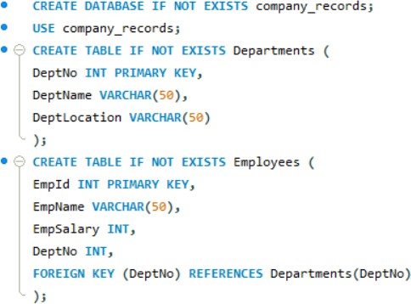

[Inserting Records]:
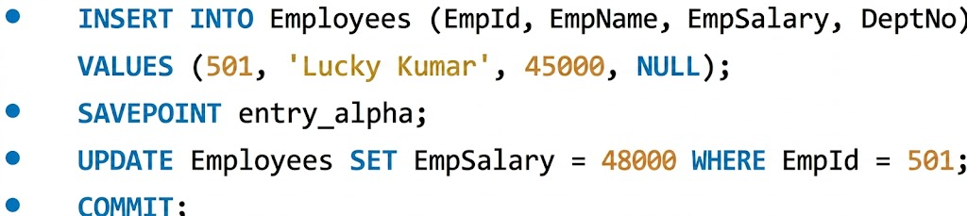

- Develop a query to grant all privileges of employees table into departments table.

- Develop a query to grant some privileges of employees table into departments table.

- Develop a query to revoke all privileges of employees table from departments table.

- Develop a query to revoke some privileges of employees table from departments table.

- Write a query to implement the save point.

OUTPUT:
